
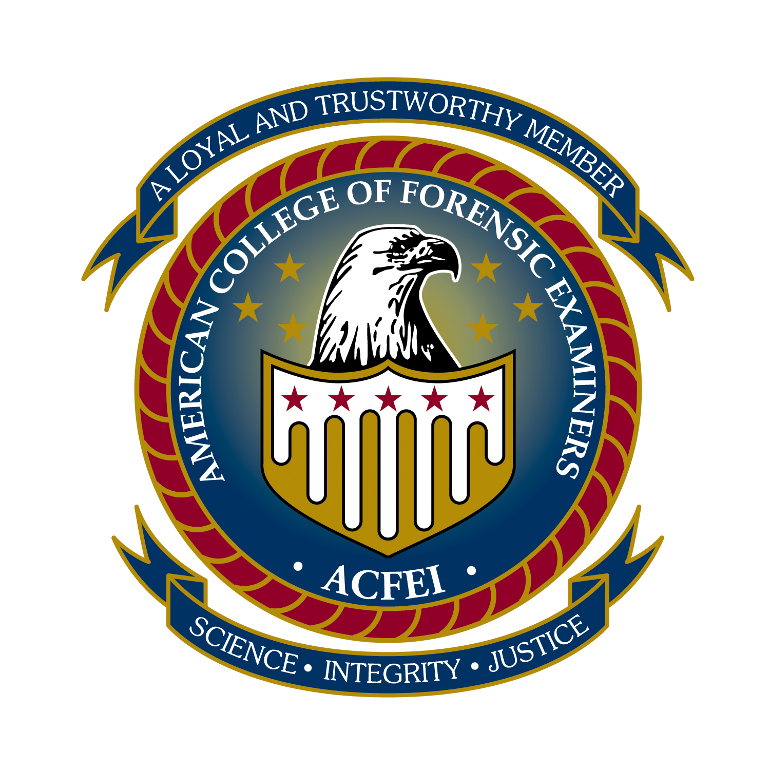
Forensic Consultation & Counseling Service, LLC
162 N. Main St. Rutland, VT 05701-3024
Office: 1-866-639-9573 (voice or fax)
Email: info@fccsvt.com

PAPERLESS BILLING OPTION

Forensic Consultation & Counseling Service, LLC is pleased to be able to offer its customers the convenience of electronic billing. If desired, your monthly statements can be conveniently e-mailed to any account of your choice when they become available. To begin this service; simply fill out the information below and return with your current payment.

If you have any concerns or questions, do not hesitate to contact our office.

Name: __________________________________ ID: ______________________________

Enroll me in the electronic billing system.

My preferred email address is: _____________________________________________________

I understand if I elect electronic billing, I am still responsible for timely payments. Any statement not received is my responsibility to contact the office and request a copy.

__________________________________________ ________________________
Signature Date

